**锅盖标定**

**Lid pattern noise correction**

**V4.0**

|  |  |  |
| --- | --- | --- |
| **版本** | **时间** | **说明** |
| **V1.0** | 2019-12-12 | 初始版本 |
| **V2.0** | 2020-02-22 | 3.x固件版本 |
| **V3.0** | 2020-8-22 | 修改锅盖标定功能相关的命令接口为新的SDK接口 |
| **V4.0** | 2021-05-17 | 适配ASIC相关的指令 |

**概述Overview：：**

Tiny红外模组集成到整机中后，需要锅盖标定才可获得较好的成像及测温效果。本文系统的介绍了锅盖标定实现流程。锅盖标定计算在模组固件中已经实现，上位机只需调用相关命令接口按照标定流程操作即可完成标定过程。相关的命令用法参考SDK中libirsdk.chm接口说明文档。

When the user integrates the module into the whole machine, it will inevitably cause a certain temperature measurement deviation due to the changes of thermal distribution and optical structure (add window, etc.). Therefore, Secondary calibration& Lid pattern noise correction is required in the whole machine. The Lid pattern noise correction has been realized in module firmware, and the master terminal only needs to call the relevant command interface to complete the calibration process. Refer to the libirsdk. chm interface description in the SDK.

**锅盖标定说明Description**

1. 将模组安装好并确保当前模组达到热稳定状态(见图A，锅盖现象可能没那么严重)；

Install the module and ensure that the module is thermally stable (see Figure A);

1. 调用set_prop_auto_shutter_params函数的SHUTTER_PROP_SWITCH为0，关闭自动快门。

Call set_prop_auto_shutter_params function with SHUTTER_PROP_SWITCH 0 to close the auto FFC.

1. 调用ooc_b_update函数，参数为B_UPDATE，进行快门校正将一温度均匀的物体对着模组(距离模组20mm左右)；

Call ooc_b_updata function with parameter B_UPDATE to conduct FFC and an object with uniform temperature against the module (about 20mm away from the module);

1. 发送锅盖标定命令rmcover_auto_calc，zoom_scale设置为1，3秒后即可拿开；

Send Lid pattern noise correction command rmcover_auto_calc； zoom_scale set to 1；3 seconds later, it can be removed;

1. 去锅盖后的效果如图B；

The effect is shown in figure B;

1. 调用set_prop_auto_shutter_params函数的SHUTTER_PROP_SWITCH为1，打开自动快门。

Call set_prop_auto_shutter_params function with SHUTTER_PROP_SWITCH as 1 to open the auto FFC.

*标定失败后，再重新进行标准锅盖标定即可。

* If the calibration fails, re-execute the process.

*若模组为高低增益版本，需要分别标定锅盖形状。

* If the module is a high-low gain version, the lid pattern noise needs to be calibrated separately.

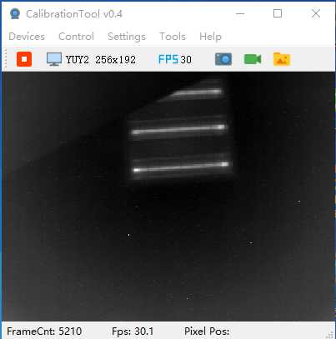 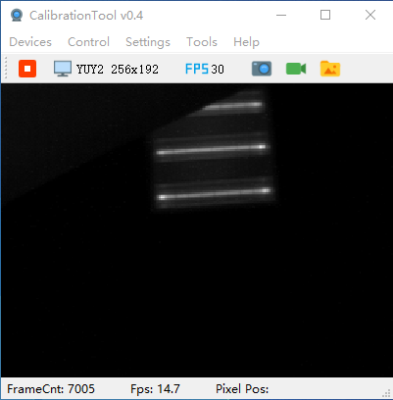

图A 图B